LONDON

READING COMPREHENSION

Read the text carefully.

London is the capital city of the United Kingdom. It is the largest city in Britain. It has got a population of about 7 million people. It is a very old city. It was founded by the Romans. Three hundred years ago, in 1666 there was a big fire – The Fire of London. Many houses burnt but only six people died in the fire.

London is famous for many things. The original area is the City. There are thousands of offices and banks but only a few people live here.

You can see Nelson’s Column in Trafalgar Square. There are two fountains in the square and you can feed pigeons here.

The Tower of London was built in the 11th century. It was a prison but now it is a museum. You can see the Crown Jewels here. Tower Bridge is near the Tower of London. It was opened in 1894.

Westminster Abbey is a beautiful church where the Coronation Ceremony takes place. Westminster Abbey is in west London, near the Houses of Parliament where you can see and hear the famous clock Big Ben.

Hyde Park is the most popular park in London. At Speakers’ Corner anybody can speak about anything (except the Queen).

The Queen lives in Buckingham Palace. The Palace has huge gardens. Soldiers stand in front of the Palace. The ceremony of the Changing of the Guard is always a great tourist attraction. The guards wear special uniforms: bearskin hats (called ‘busby’), black trousers and red coats.

London stands on River Thames. There are 27 bridges over the Thames in London and 8 tunnels under the river.

A quick and easy way to get to different places in the city is to use an underground train. Londoners call the underground the ‘tube’. There are many famous red buses in London called double-deckers and London taxis are called black cabs.

1 Match the pictures to their names.

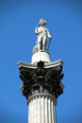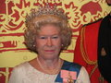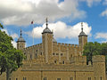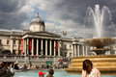 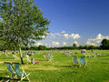

a) the Changing of the Guard

b) the Tower of London

c) Elizabeth II

d) Trafalgar Square

e) Hyde Park

f) a soldier

g) Tower Bridge

h) Nelson’s Column

i) double decker

j) Coronation Jewels

k) Westminster Abbey

l) Big Ben

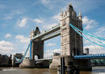

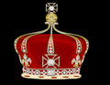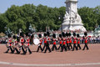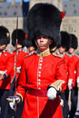

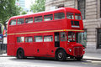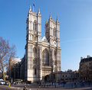

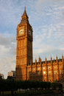

2 Decide whether the statements are true or false. Correct the false ones.

1 London was founded by Romanians. ⬜

2 Six buildings burnt in the Fire. ⬜

3 Not many people live in the city. ⬜

4 There are lots of pigeons in Trafalgar Square. ⬜

5 Big Ben is a famous tower next to the Houses of Parliament. ⬜

6 You can speak about the Queen at Speakers’ Corner. ⬜

7 Busby is a part of soldiers’ uniform. ⬜

8 The Changing of the Guard is not very interesting. ⬜

9 There are eight bridges in London over the Thames. ⬜

10 London buses are red and have two floors. ⬜

3 Answer the questions.

1 What is the biggest city in the UK? ______________________________

2 When was the Big Fire? ______________________________

3 What can you see in the Tower of London? ________________________

4 Where does the Queen live? _______________________________

5 What do guards wear? _______________________________

   WELL DONE!