Eating out
* * * * * * * * * * * * * * * * * * * * * * * * * * * * * * * * * * * * * * * * * *
The end task you are supposed to do is write a text about your favourite eating places. Activities A and B will provide you the input for Activity C.

ACTIVITY A2312456+6
1. Fill in the table with 6+t6hree examples under each heading. done

Fruit   | Vegetables   | Meat / Fish  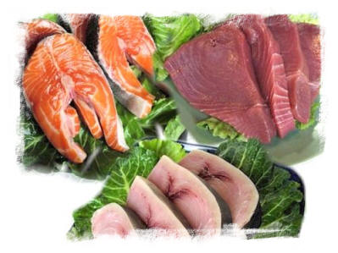 | Dairy products  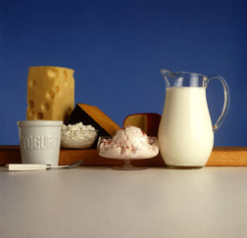 | Groceries  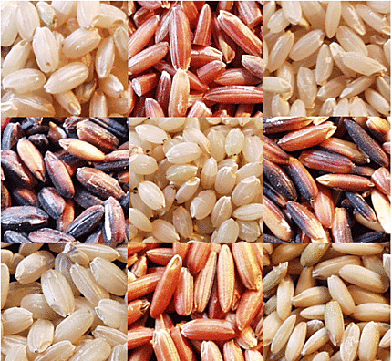
a.  b.  c. | d.  e.  f. | g.  h.  i. | j.  k.  l. | m.  n.  o.

2. Match the eating places with the corresponding definitions. In your answer write the numbers and the letters only. done
Eating places | Definitions
- Fast food restaurant  - Take away  - Cafeteria  - Self-service restaurant  - Pub  - Restaurant | a. A place which serves cheap meals and has no table service.  b. A place which serves fish and chips, hamburgers, ice cream, etc.  c. You can go there for a drink and meet friends. You can also have something light to eat.  d. An establishment where you can eat a slice of cake and drink a cup of coffee, a cup of tea or a capuccino.  e. A place where you can sit down and be served by a waiter.  f. An establishment where you can buy some food and eat it somewhere else.

3. Complete the text with the words from the box. In your answer write the numbers and the letters only.
In many .......a.....countries it is normal to have a long break in the middle of the day when all members of the family ..........b..........to their houses to eat together. This is not very .........c.........in Britain because normally it is a long way from the place of work or school to the home. Consequently the British people tend to have a big .........d........before they go to work and the meal at .........e.......is not spent with the members ........f........ the family but with workmates or schoolmates. Lunch is .......g.......eaten between 12.30 pm and 1.30pm. Most people finish work at five thirty. It often ........h.........at least an hour to get home from the school or workplace so people tend to eat their evening meal or "dinner" between 6.30pm and 8pm.
On Sundays people don't have to work so they take the opportunity to eat .........i..........with their family. Sunday lunch is usually the best meal of the week and many of the .........j........which are considered typically British are eaten for Sunday lunch. For example roast beef and Yorkshire pudding.
1. meals 2. midday 3.of 4. together 5.European 6.takes 7. breakfast 8. common 9.return 10. normally

ACTIVITY B
Read the following text:
Cyber Café
My name is Evan Galbraith and I founded the Cyber Café about 11 years ago, in New York. When the Internet boom began, I was intrigued by a similar idea in London, England, called CYBERIA, which as far as I know was the very first Internet café.
In June 1995, when we opened our first establishment on the corner of Prince and Lafayette Streets, two other Internet cafés had also opened in the East Village. Today, there are thousands of Internet cafés all over the world.
Internet cafés come in all shapes and sizes: some have over 1,000 computers, others just one; some offer a full menu and some no food or drinks at all; some allow customers to use the computers for free but others charge by the hour. So what makes Cyber Café different?
We designed Cyber Café to be very comforting. It is a perfect place to hang out, chat with friends, play billiards or just relax in a comfortable area while enjoying our delicious specialty café offerings, the light panel walls, the relaxing selection of furniture and our impressive 6 x 8 foot media entertainment screen. At Cyber Café, you can check your e-mail, send e-cards or digital photos, play computer games or listen to the latest news over a delicious cappuccino. There is also a wide variety of teas, frozen drinks, refreshing milk shakes, ice creams, our famous gourmet dessert and a selection of sandwiches, salads, cakes and cookies.
At night, people can also enjoy a nice glass of wine while they surf the web and watch MTV, headline news, or a major sporting event. We also have an on-going art gallery with exhibitions from all over the world.
I have always believed that the combination of a unique, relaxing atmosphere and superb service is essential to the growth of public Internet facilities. The last 11 years have been so much fun and I hope you will enjoy the CYBER CAFÉ experience as much as I do!

1. Find in the text ( 3rd and 4th paragraphs ) the synonyms of the following words.

a. complete b. clients c. be with friends d. talk

2. Use the information provided in the text to complete the diagram below.

CYBER CAFÉ | Internet activities  that you can do there |  | ►a.  ►b.  ►c.  ►d.
CYBER CAFÉ | What food/ drinks you can have there | Food | ►e.  ►f.  ►g.  ►h.
CYBER CAFÉ | What food/ drinks you can have there | Drinks | ►i.  ►j.  ►k.

3. Say whether the following sentences are true or false. Correct the false sentences and find evidence for the true ones.

a. Cyber café was the first Internet Café.
b. There are many different types of Internet cafés.
c. Cyber café is closed at night.
d. Cyber café is very popular because it has an excellent service and a friendly atmosphere.
4. Answer the following questions about the text. Write complete sentences.
a. When did the first Cyber Café open?
b. How can people enjoy themselves at Cyber café, besides using the Internet?
c. Why is the art gallery so special?
d. What's your opinion about the Cyber Café? Would you like to go there? Why/ Why not?
5. Fill in the gaps with a relative pronoun or adverb.

a. They ate a special burger .... was recommended by the restaurant's owner.
b. Do you remember the day .... we tried a special Japanese dish?
c. I only choose restaurants .... I can eat vegetarian food.
d. This is the cafeteria ..... cakes are delicious.
e. Whiskey is a famous drink... is served in British pubs.
6. Join the two sentences using a relative pronoun or adverb.

a. That's the famous chef. He prepares the most amazing dishes.
b. The Italian restaurant is always crowded. It serves excellent pizzas.
c. My friend is very fat. His favourite food is fast food.
7. Read the sentences a. to e. and pay attention to the modal verbs in bold. Then match each sentence to their meaning. In your answer refer only to the letters and the numbers.
Sentences |  | Meaning
a. You can eat Chinese food in London. |  | - advice  - request  - prohibition  - possibility  - permission
b. You may go to the pub tonight.
c. You should eat less fast food.
d. Would you go out with me?
e. People mustn't smoke in some restaurants.

8. Choose the most appropriate modal verb to complete the sentences. In your answer write the letters and the numbers only.

a. Drinking too much soda ...... be harmful.
1. may 2. mustn't 3. should

b. Children .... eat too many sweets.
1. may 2. mustn't 3. should

c. People .... eat less fast food.
1. should 2. mustn't 3. can

d. .... you pass me the water please?
1. Should 2. Could 3. Can

ACTIVITY C

Write about your two favourite eating places and explain why you like them so much. Refer to their characteristics and what people can eat and do there.

